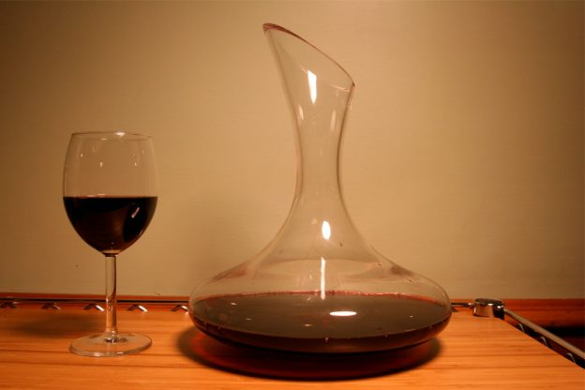

The wine decanter is a fairly standard vessel found in many glassware collections.But it’s also a rather mysterious object that inspires questions about how to use it, and what function decanting actually serves. So, what does it mean to decant wine?葡萄酒滗水器是许多玻璃器皿系列中相当标准的容器。但它也是一个相当神秘的对象，激发了关于如何使用它的问题，以及滗析实际上起作用的功能。那么，滗水酒意味着什么呢？Simply put, decanting involves pouring wine (or any liquid) from one container into the decanter. While some decanting serves more to ornament the presentation of a dining experience, decanting certain wines has an evident effect on their aroma and drinkability. 简单地说，倾析涉及将葡萄酒（或任何液体）从一个容器倒入滗析器中。虽然一些倾析更多地用于装饰用餐体验的呈现，但倾析某些葡萄酒对其香气和可饮用性具有明显影响。As wine ages, its organic molecules grow larger through polymerization,which reduces its astringency and makes the wine softer, less chalky. But over time, a wine may deposit crystal tartrates and pigmented organic substances called tannins that collect as sediment at the bottom of a bottle. 随着葡萄酒的老化，其有机分子通过聚合变大，从而降低其涩味，使葡萄酒更柔软，更少白垩。但随着时间的推移，葡萄酒可能会沉积出酒石酸晶体和被称为单宁的有色有机物质，这些物质会在瓶底收集沉淀物。Decanting separates out those sediments that build up. This is usually only required for high-end wines, with a vintage date over 10 years. 倾析分离出那些积聚的沉积物。这通常只适用于葡萄酒日期超过10年的高端葡萄酒。Decanting can also help to release volatile compounds in wine that mask its subtle flavors. These volatiles are a combination of organic compounds that add aromas—such as fruit, oak,tars, esters, and aldehydes.倾析还可以帮助释放葡萄酒中的挥发性化合物，掩盖其微妙的味道。这些挥发物是有机化合物的组合，可以增加香气，如水果，橡木，焦油，酯和醛。Decanting a young wine incorporates oxygen that helps to evaporate any harsh volatiles. Now, the wine’s tastes and smells will be more discernible than the astringent alcohol.Red wines acquire their chemical characteristics because they are held in relatively oxygen free environments during aging in bottles. White wines, however, don’t benefit from decanting because they aren’t aged in bottles long before serving. So, feel free to skip decanting your Chardonnay, but if Malbec is on the menu, bring out the decanter—for sake of showmanship and flavor.倾倒年轻的葡萄酒含有氧气，有助于蒸发任何刺激性的挥发物。现在，葡萄酒的味道和气味比涩味酒更明显。红葡萄酒具有化学特性，因为它们在瓶装陈酿过程中保存在相对无氧的环境中。然而，白葡萄酒不能从倾倒中获益，因为它们在服用之前很久就不会被装瓶。所以，请随意跳过滗出你的霞多丽，但如果马尔贝克在菜单上，拿出滗水器 - 为了表演和风味。